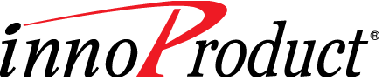

*InnoProduct*

*Rule Service Guide of*

*Product Builder*

InnoProduct v5.1



InnoProduct Version 5.1 Copyright © 2007-2016 INNORULES Corporation. All rights reserved.

InnoProduct® and InnoRules® are registered trademarks of INNORULES Corporation.

目次

Chapter 1. Overview 5

1． Object Type/Type 5

2． Object semi-Type 5

3． Object 5

4． Relation 5

5． Relation Object 5

6． Relation Type 5

7． Relation Rule 5

8． Relation Condition 6

9． Attribute 6

10． Table Property 6

11． Effective Period 6

Chapter 2. InnoProduct Product Repository 7

12． Type and Attribute Area 8

12.1 OBJ1000 9

12.2 OBJ1100 11

12.3 OBJ1110 13

12.4 OBJ1200 15

12.5 OBJ1400 18

13． Object / Attribute value / Table property Area 20

13.1 OBJ_MAIN 21

13.2 OBJ_DETAIL 23

13.3 OBJREL_INC 25

13.4 OBJRELINC_PROP 27

Relation and Relation Rule Area 29

14． 29

14.1 OBJINV_TYPE 29

14.2 OBJ_INV 31

Chapter 3. Common information inquiry 34

15． VF_DT、VT_DT 34

16． END_DT 34

Chapter 4. Querying structural information 35

17． Object 35

17.1 Query General Product list 35

17.2 Query Car Product list 35

17.3 Query products with a specific code 36

17.4 Query products with a specific name 36

17.5 Query entire product list 37

18． Relation 38

19． Relation Rule 39

20． Service View 41

20.1 Service View list 41

20.2 Service View Structure 42

Chapter 5. Attribute Info 43

21． Attribue 43

22． Single Value of Attribute 44

23． Multiple Value of Attribute 45

Chapter 6. Table Property 46

Chapter 7. Other 47

24． Query product list with specific attribute values 47

25． Query product list with specific coverage in the lower level 48

26． Query a list of products that have coverage with a specific attribute value in the lower level 49

27． When the attribute value is a rule 50

Chapter 8. Creating SQL with Rule Builder 51

図目次

[Image 1 管理類型および標準項目関連領域テーブル] 8

[Image 2 管理類型の登録／修正画面] 10

[Image 3 標準項目の登録／修正 – 項目グループ管理ポップアップ画面] 12

[Image 4 標準項目の登録／修正画面] 14

[Image 5 標準項目の登録／修正画面] 17

[Image 6 標準項目の登録／修正 – 入力項目画面] 19

[Image 7 オブジェクト・標準項目値・表属性情報関連領域テーブル] 20

[Image 8 商品構造の登録／修正画面] 22

[Image 9 商品項目の登録／修正画面] 24

[Image 10 商品項目の登録／修正画面] 26

[Image 11 商品項目の登録／修正 – マルチ項目値の追加入力部分] 28

[Image 12 関係および関係ルール関連の領域テーブル] 29

[Image 13 関係ルールの登録／修正 - 関係類型管理ポップアップ画面] 30

[Image 14 商品構造の登録／修正画面] 32

[Image 15 関係ルールの登録／修正画面] 32

1. Overview

This document contains information on the physical model of the product repository for developing the product information rule service, and the contents of rule service development using it.

The product information rule service is a rule created to provide application information (structure, relation, relation rule, attribute / attribute value, table property, etc.) stored in the product repository of InnoProduct to the application. The service uses a database rule to query the product repository, process the relevant results, and provide them to the application.

The following terms are used in this document.

# Object Type/Type

A type is an abstraction of real objects. There are also table property types and service view types to manage table property and service view information. (Hereafter, object omitted)

# Object semi-Type

More specific than type, more abstract than object. (Hereafter, object omitted)

# Object

Real thing. Among Type, semi-Type, and object, the most specific. It has attributes.

# Relation

It means the upper / lower structure of objects.

# Relation Object

InnoProduct creates a new object that represents the relation itself when linking objects in a vertical relation.　It has also attributes.

# Relation Type

Means the vertical relationship between semi-Types.

# Relation Rule

This is a restriction / limitation between objects located in the lower level.

# Relation Condition

When defining constraints / restrictions in relation rules, they are used as expressions that represent constraints / restrictions.

# Attribute

This is standard information managed per semi-Type. Define and manage detailed information of attributes (attribute group, business category, data / screen / value / column type, multiple rule category, etc.) used for each semi-Type.

# Table Property

In general, attributes have one item as one semantic unit, but table attributes have a set of multiple items as one semantic unit.

# Effective Period

This is the period during which attribute values registered by object are applied.

1. InnoProduct Product Repository

In this document, only tables related to Types, objects, attributes, attribute values, structures, and table properties used by the rule service will be described. The information provided by InnoProduct through the rule service is as follows.

* Structure (object, relation, relation rule, service view)
* Attribute, Attribute values
* Table property

The sample data in this document was prepared assuming insurance business.

Refer to InnoProduct Repository Specification for detailed information about the tables described.

# Type and Attribute Area

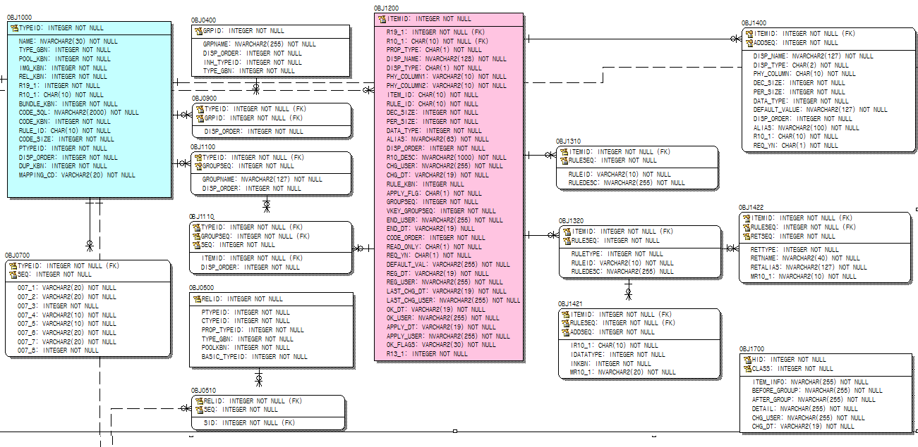

**OBJ1000**

**OBJ1200**

**OBJ1100**

**OBJ1110**

**OBJ1400**

[Image 1 Type and Attribute Area Table]

## OBJ1000

This table stores the types managed by InnoProduct.

[Table 1 Main Column]

|  |  |  |
| --- | --- | --- |
| Column Name | Description | Remarks |
| TYPEID | Type ID |  |
| TYPE_GBN | Code Values that distinguish Object for example, Type, Table Property, Service View | 0: Allowed Value  1: Type  5: Table Property  6: Service View |
| REL_KBN | Code Values that distinguish Type. For Example, Type, Relational Type | 1: Type  2: Relational Type |
| PTYPEID | Upper level type ID when it is a semi-Type | TYPEID stored in OBJ1000 |
| MAPPING_CD | Upper level type ID when it is a table property | TYPEID stored in OBJ1000 |

[Table 2 Sample Data]

|  |  |  |  |  |  |  |  |
| --- | --- | --- | --- | --- | --- | --- | --- |
| TYPEID | NAME | TYPE_GBN | REL_KBN | R10_1 | PTYPEID | DISP_ORDER | MAPPING_CD |
| 0 | Allowed Value | 0 | 0 | #S00000001 | -1 | 9,999 |  |
| **10** | **Product** | **1** | **0** | **#S00000002** | **-1** | **1** |  |
| **20** | **Coverage** | **1** | **0** | **#S00000003** | **-1** | **2** |  |
| **901** | **General** | **1** | **0** | **#S00000005** | **10** | **1** |  |
| **902** | **Car** | **1** | **0** | **#S00000006** | **10** | **2** |  |
| **911** | **General** | **1** | **0** | **#S00000005** | **20** | **1** |  |
| **912** | **Car** | **1** | **0** | **#S00000006** | **20** | **2** |  |
| 921 | **General** | 1 | 1 | #S00000005 | 1,020 | 1 |  |
| 922 | **Car** | 1 | 1 | #S00000006 | 1,020 | 2 |  |
| 1,001 | Car’s Table Property | 5 | 0 |  | -1 | 9,999 | 902 |
| 1,002 | Payment period Table Property | 5 | 0 |  | -1 | 9,999 | 921 |
| 1,020 | Product-Coverage | 1 | 1 | #S00000004 | -1 | 3 |  |
| 5,000 | Service View | 6 | 0 | #S00000061 | -1 | 9,999 |  |
| 5,001 | General | 6 | 0 | #S00000005 | 5,000 | 9,999 |  |
| 5,002 | Car | 6 | 0 | #S00000006 | 5,000 | 9,999 |  |

Table Description

Types of Product and Coverage are generated with TYPEIDs of 10 and 20.

General and Car are generated with TYPEIDs of 901 and 902, which are semi-Types of Products, and General and Car are generated with TYPEIDs of 911 and 912, which are semi-Types of Coverage.

The value of the PTYPEID column stores the upper Type TYPEID.

The semi-Type of the Product is 901 (General), 902 (Car) with a PTYPEID column value of 10 (Product), and the semi-Type of Coverage is 911 (General), 912(Car) with a PTYPEID column value of 20 (Coverage).

* Related Screen

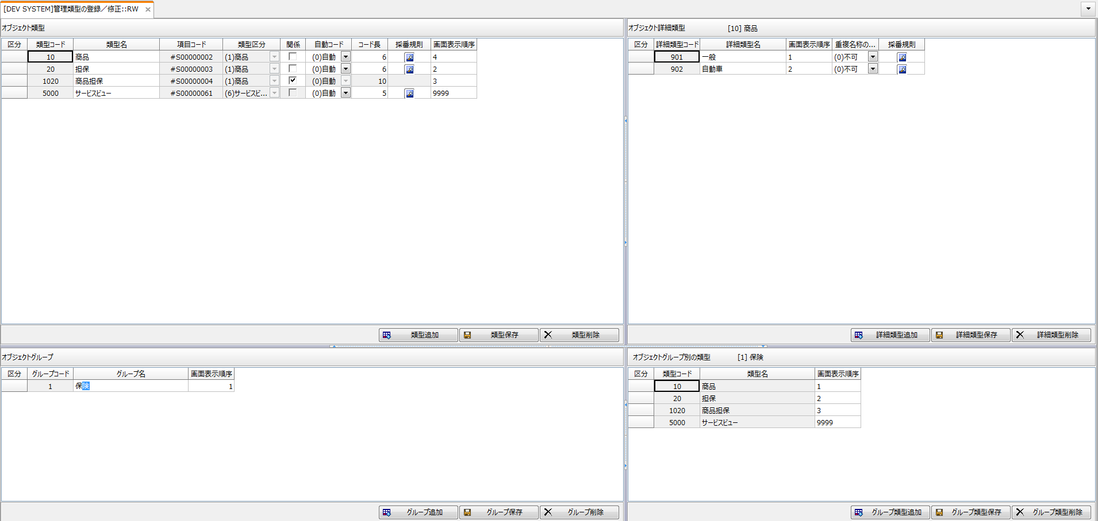

[Image 2 管理類型の登録／修正画面]

## OBJ1100

It is a table for storing Attribute group information for each semi-Type defined in OBJ1000.

[Table 3 Main Column]

|  |  |  |
| --- | --- | --- |
| Column Name | Description | Remarks |
| TYPEID | Type ID | TYPEID stored in OBJ1000 |

[Table 4 Sample Data]

|  |  |  |  |
| --- | --- | --- | --- |
| TYPEID | GROUPSEQ | GROUPNAME | DISP_ORDER |
| 901 | 1 | Basic | 1 |
| 901 | 2 | Other | 2 |
| 902 | 1 | Basic | 1 |
| 902 | 2 | Other | 2 |
| 911 | 1 | Basic | 1 |
| 911 | 2 | Other | 2 |
| 912 | 1 | Basic | 1 |
| 912 | 2 | Other | 2 |
| 921 | 1 | Basic | 1 |
| 921 | 2 | Other | 2 |
| 922 | 1 | Basic | 1 |
| 922 | 2 | Other | 2 |
| 1,001 | 1 | Car’s Table Property | 999 |
| 1,002 | 1 | Payment period Table Property | 999 |

* Related Screen

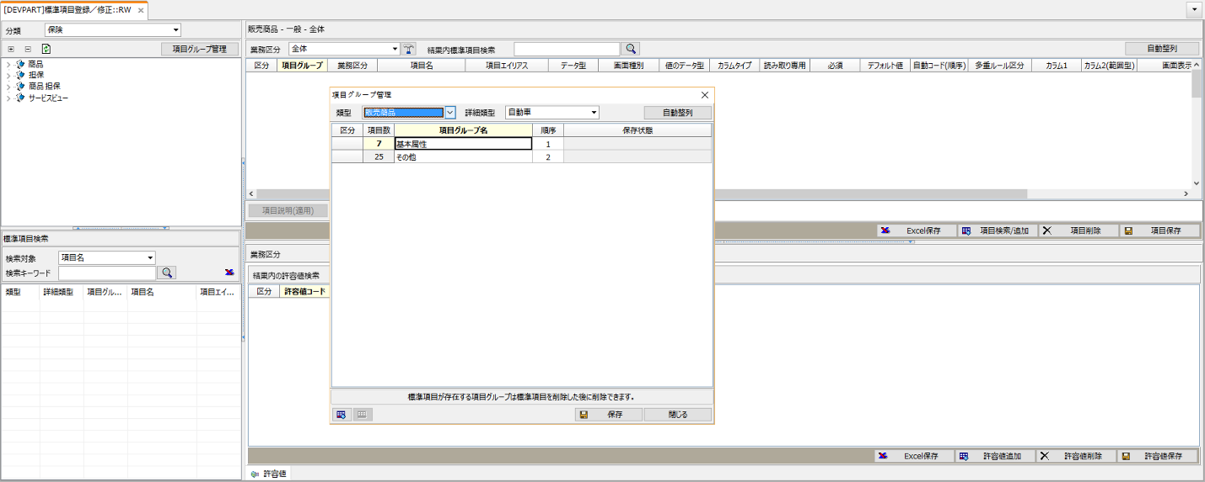

[Image 3 標準項目の登録／修正 – 項目グループ管理ポップアップ画面]

## OBJ1110

It is a table for storing a list of Attributes that a Attribute Group has.

[Table 5 Main Column]

|  |  |  |
| --- | --- | --- |
| Column Name | Description | Remarks |
| TYPEID | Type ID | TYPEID stored in OBJ1000 |
| GROUPSEQ | Order in Attribute Group | GROUPSEQ of Attribute Group stored in OBJ1100 |
| ITEMID | Attribute ID | ITEMID stored in OBJ1200 |

[Table 6 Sample Data]

|  |  |  |  |  |
| --- | --- | --- | --- | --- |
| TYPEID | GROUPSEQ | SEQ | ITEMID | DISP_ORDER |
| 901 | 1 | 15 | 78 | 999 |
| 901 | 1 | 16 | 79 | 999 |
| 901 | 1 | 17 | 80 | 999 |
| 901 | 1 | 18 | 81 | 999 |
| 901 | 1 | 19 | 82 | 999 |
| 901 | 1 | 20 | 83 | 999 |
| 901 | 1 | 21 | 84 | 999 |
| 901 | 1 | 22 | 85 | 999 |
| 901 | 1 | 23 | 86 | 999 |
| 911 | 1 | 7 | 87 | 999 |

Table Description

In this table, information of OBJ1100 and OBJ1200 is linked.

* Related Screen

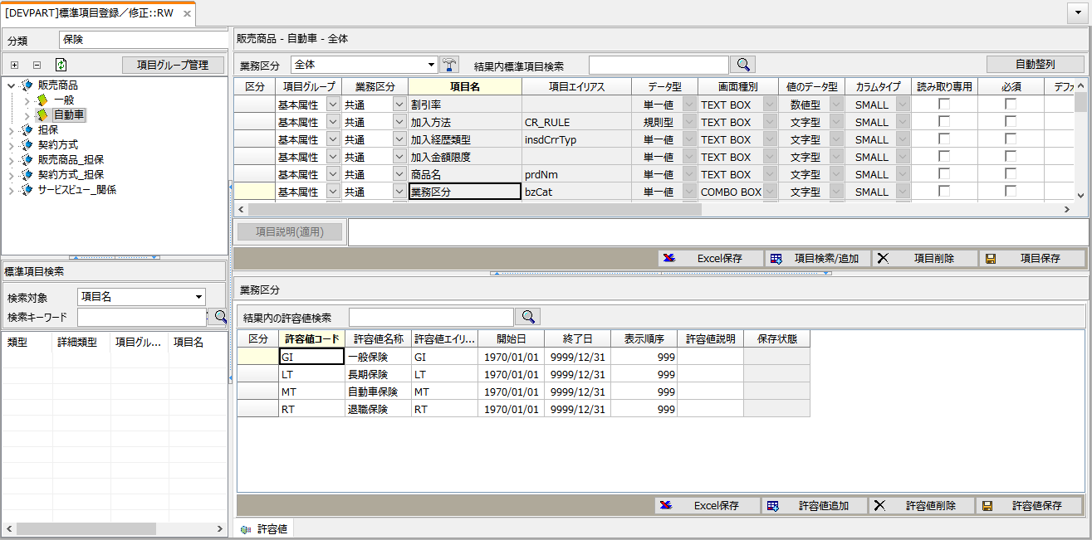

[Image 4 標準項目の登録／修正画面]

## OBJ1200

It is a table that stores meta information of Attributes for each semi-Type.

[Table 7 Main Column]

|  |  |  |
| --- | --- | --- |
| Column Name | Description | Remarks |
| **ITEMID** | Attribute ID |  |
| **R10_1** | Code value of rule item | Attributes are stored in the repository as rule items. |
| **PROP_TYPE** | Code Values that distinguish Item values. For Example, Single, Multi, Rule Type, Range Type | 1: Single  2: Multi  3: Rule Type  4: Range Type |
| **DISP_NAME** | Attribute name displayed on the screen |  |
| **DISP_TYPE** | Type of attribute displayed on the screen | 1: TEXT BOX  2: COMBO BOX  3: CHECK BOX  5: DATE |
| **PHY_COLUMN1,2** | Column name of OBJ_DETAIL table where attributes are stored  -PHY_COLUMN2 is used only for range type | CHAR01, CHAR02, TEXT01… |
| **ITEM_ID** | Item code(R10_1) for displaying allowed values for attributes | In case of using the allowed values of another item, the value of R10_1 of that item is stored |
| **DATA_TYPE** | Code Values that distinguish data types | 1: Numeric Type  2: Character Type |
| **ALIAS** | Alias for Attribute |  |
| **RULE_KBN** | Code Values that distinguish Attribute’s extra type. For examples, Execution Rule and Input Item. | 0: None  1: Input Item  2: Execution Rule |
| **DISP_ORDER** | Display Order |  |

[Table 8 Sample Data]

|  |  |  |  |  |  |  |  |  |  |  |
| --- | --- | --- | --- | --- | --- | --- | --- | --- | --- | --- |
| ITEM  ID | R10_1 | PROP_ TYPE | DISP_ NAME | DISP_ TYPE | PHY_COLUMN1 | PHY_COLUMN2 | ITEM_ ID | DATA_ TYPE | ALIAS | DISP_ ORDER |
| 36 | #S00000008 | 1 | Product Name | 1 | CHAR09 |  | #S00000008 | 2 | PRD_NM | 999 |
| 37 | #S00000009 | 1 | Business Catalog | 2 | CHAR10 |  | #S00000009 | 2 | BZ_CAT | 999 |
| 41 | #S00000010 | 1 | Car Product Group | 2 | CHAR14 |  | #S00000010 | 2 | AUTO_PRDGR | 999 |
| 28 | #S00000029 | 1 | Existence of traffic law violation types | 1 | CHAR01 |  | #S00000029 | 2 | TRFC_LAW_VIOL_CAT_YN | 999 |
| 29 | #S00000031 | 1 | Named insured driving | 1 | CHAR02 |  | #S00000031 | 2 | NM_PLYHDR_DRV_YN | 999 |
| 30 | #S00000030 | 1 | Basic insurance premium rate | 2 | CHAR03 |  | #S00000030 | 2 | BAS_PREM_RNGE_PREM_RT | 999 |
| 31 | #S00000020 | 1 | Existence of short-term contract | 1 | CHAR04 |  | #S00000020 | 2 | SHTMCT_EXST_YN | 999 |

Table Description

This table stores meta information of Attribute such as data type, screen display name, screen type, column position.

* Related Screen



[Image 5 標準項目の登録／修正画面]

## OBJ1400

When the RULE_KBN column value of the OBJ1200 table is 1 (input item), this table stores meta information of the input item.

[Table 9 Main Column]

|  |  |  |
| --- | --- | --- |
| Column Name | Description | Remarks |
| **ITEMID** | Attribute　ID |  |
| **ADDSEQ** | Sequence |  |
| **DISP_NAME** | Display Name on the screen |  |
| **DISP_TYPE** | Display Type on the screen | 1：TEXT BOX 2：COMBO BOX |
| **PHY_COLUMN** | Column name of the OBJRELINC_PROP table where input items are stored | CHAR01, CHAR02, NUM01… |
| **DATA_TYPE** | Data Type | 1: Numeric Type  2: Character Type |
| **ALIAS** | Alias for input item |  |
| **R10_1** | Code value of rule item that is linked input item |  |

[Table 10 Sample Data]

|  |  |  |  |  |  |  |  |
| --- | --- | --- | --- | --- | --- | --- | --- |
| ITEMID | ADDSEQ | DISP_NAME | DISP_TYPE | PHY_COLUMN | DATA_TYPE | ALIAS | R10_1 |
| 110 | 1 | Insurance Career Type | 2 | CHAR01 | 2 | insdCrrTyp | #S00000040 |
| 110 | 2 | Discount Rate | 1 | NUM01 | 1 |  | #S00000064 |

Table Description

This table stores meta information of input items such as display order, screen name, data format, column, screen type.

* Related Screen

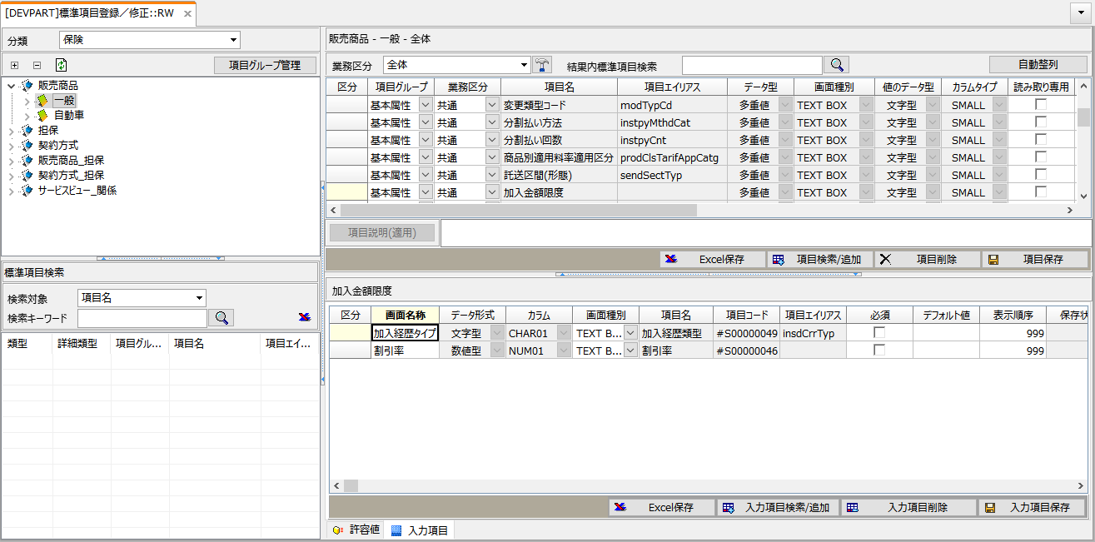

[Image 6 標準項目の登録／修正 – 入力項目画面]

# Object / Attribute value / Table property Area

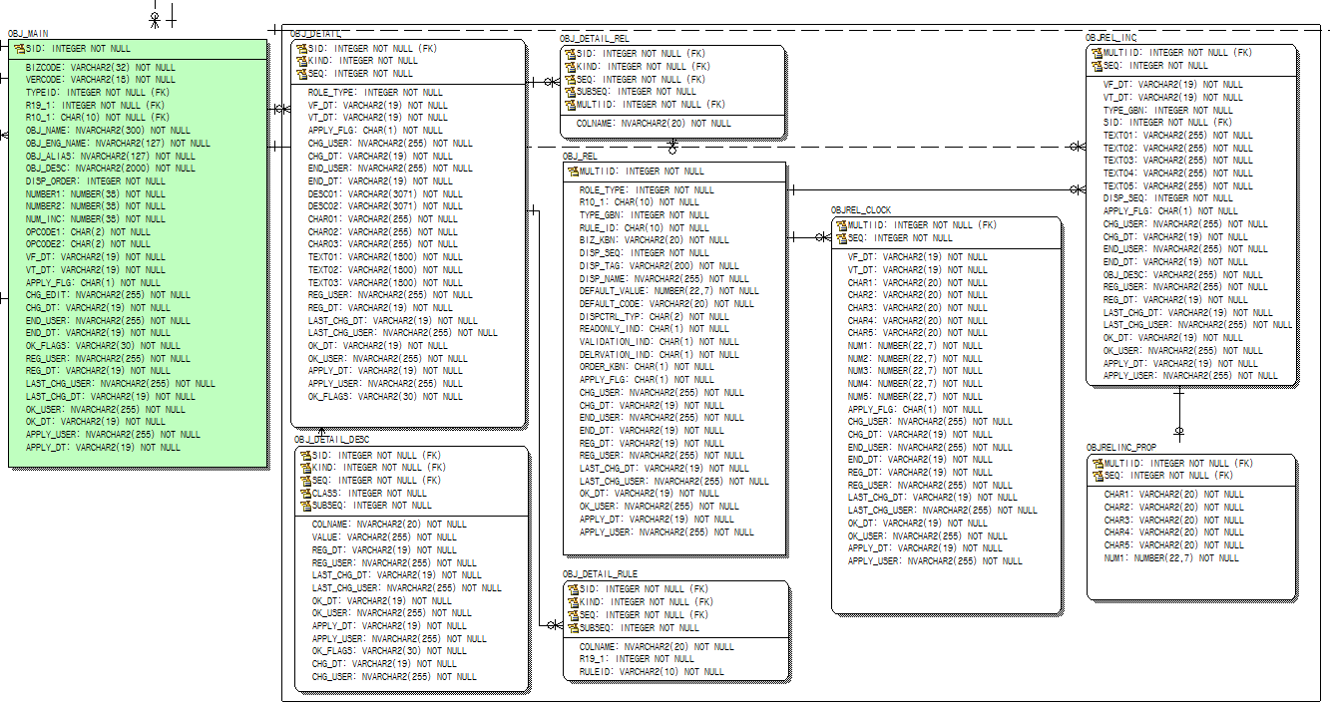

**OBJ_MAIN**

**OBJ_DETAIL**

**OBJREL_**

**INC**

**OBJRELINC_PROP**

[Image 7 オブジェクト・標準項目値・表属性情報関連領域テーブル]

## OBJ_MAIN

This table stores information such as objects and service views.

[Table 11 Main Column]

|  |  |  |
| --- | --- | --- |
| Column Name | Description | Remarks |
| **SID** | Automatically generated object ID |  |
| **BIZCODE** | Object code generated according to predefined numbering rules |  |
| **TYPEID** | semi-Type ID | TYPEID stored in OBJ1000 |

[Table 12 Sample Data]

|  |  |  |  |
| --- | --- | --- | --- |
| SID | BIZCODE | TYPEID | OBJ_NAME |
| 261 | **P2001** | **902** | Personal car insurance |
| 262 | **I2001** | **912** | Criminal agreement support costs guarantee |
| 263 | **I2002** | **912** | Lawyer appointment costs guarantee |
| 264 | **I2003** | **912** | File fee guarantee |
| 265 | **I2004** | **912** | Hit-and-Run Accidental death guarantee |

Table Description

There is a product object whose code is P2001 and the semi-Type is a car(902), and a coverage object whose code is I2001, I2002, I2003 and I2004 and whose semi-Type is a car(912).

* Related Screen

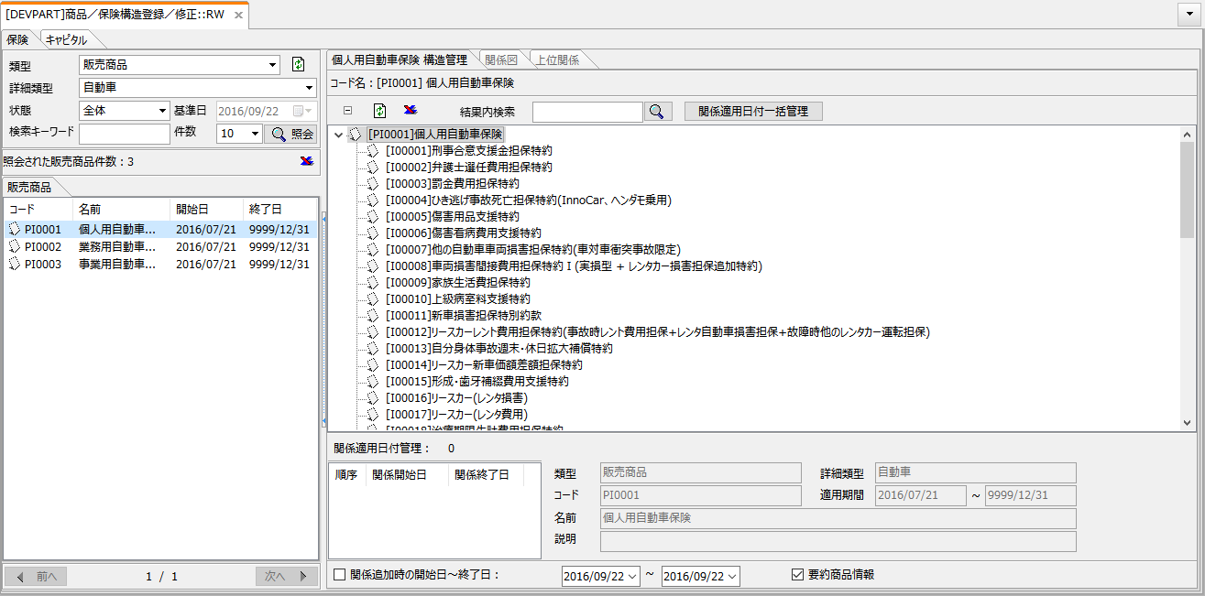

[Image 8 商品構造の登録／修正画面]

## OBJ_DETAIL

It is a table for storing Attribute values and Table Property data for each object.

[Table 13 Main Column]

|  |  |  |
| --- | --- | --- |
| Column Name | Description | Remarks |
| SID | Object ID | SID of OBJ_MAIN table |
| KIND | Code Values that distinguish target data to store | 1: Attribute  Other: TYPEID of Table Property |
| VF_DT VT_DT | Effective period of Attribute Values.  Start Date(VF_DT)/ End Date(VT_DT) Objects may have Attribute values with different effective periods. | Objects may have Attribute values with different effective periods.(YYYYMMDD) |
| CHAR01 CHAR02 CHAR03 … | The actual data value of the specified attribute is saved. It is saved to column defined in PHY_COLUMN1, 2 of OBJ1200. |  |

[Table 14 Sample Data]

|  |  |  |  |  |  |  |  |
| --- | --- | --- | --- | --- | --- | --- | --- |
| SID | KIND | VF_DT | VT_DT | CHAR01 | CHAR02 | CHAR09 | CHAR10 |
| 261 | 1 | 20150214 | 99991231 | Y | Y | Innocar Personal Car Insurance | MT |
| 261 | 1,001 |  |  |  | 19 |  |  |
| 261 | 1,001 |  |  |  | 17 |  |  |
| 261 | 1,001 |  |  |  | 20 |  |  |

Table Description

The Attribute values are stored for each object in the OBJ_DETAIL column that matches the PHY_COLUMN1 and 2 column values set in the OBJ1200 table.

If the value of the KIND column is 1, it is the value of the Attribute. Other values are table property data for each table property code.

* Related Screen

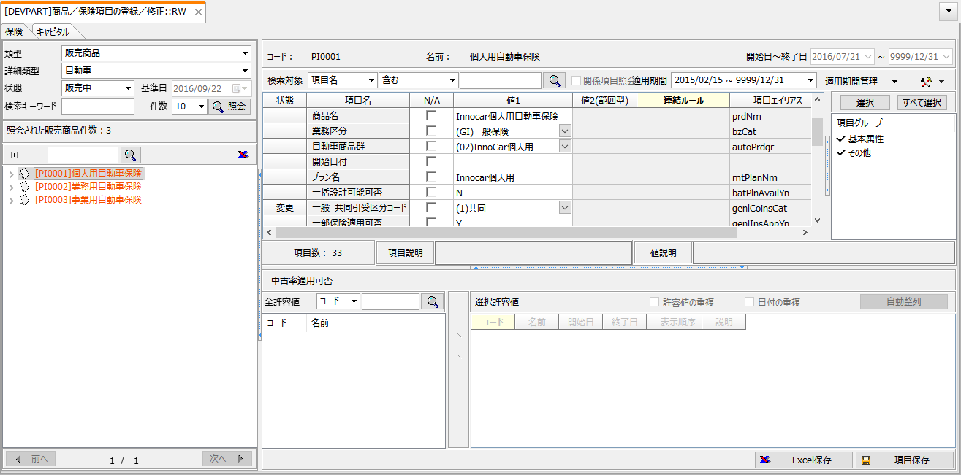

[Image 9 商品項目の登録／修正画面]

## OBJREL_INC

It is a table that stores attribute values whose PROP_TYPE column value of the OBJ1200 table is 2 (multi).

[Table 15 Main Column]

|  |  |  |
| --- | --- | --- |
| Column Name | Description | Remarks |
| **MULTIID** | Item’s Id which has multiple value. |  |
| **SEQ** | Sequence |  |
| **SID** | SID of Allowed Value |  |
| **DISP_SEQ** | Display Order |  |

[Table 16 Sample Data]

|  |  |  |  |  |  |  |  |
| --- | --- | --- | --- | --- | --- | --- | --- |
| MULTIID | VF_DT | VT_DT | SID |  | SID | BIZCODE | OBJ_NAME |
| 1 | 20150225 | 99991231 | 57 | 56 | 01 | Lump-sum payment (from 1 year) |
| 1 | 20150225 | 99991231 | 56 | 57 | 02 | Installment payment (from 1 year) |
| 1 | 20150225 | 99991231 | 58 | 28 | 03 | Automatic transfer fee continuous payment (from 1 to 2 year) |
| ▲　OBJREL_INC’s Data | | | |  | ▲　OBJ_MAIN’s Data | | |

Table Description

The OBJ_DETAIL table stores the value as it is when the data type of the Attribute is a single value.

It stores the MULTIID value of the OBJREL_INC table when the data type of the Attribute is multi-value.

The OBJREL_INC table of Sample Data has three ROWs with a MULTIID value of 1. The actual value can be seen in BIZCODE and OBJ_NAME by matching the SID of the OBJREL_INC table with the SID of the OBJ_MAIN table.

* Related Screen

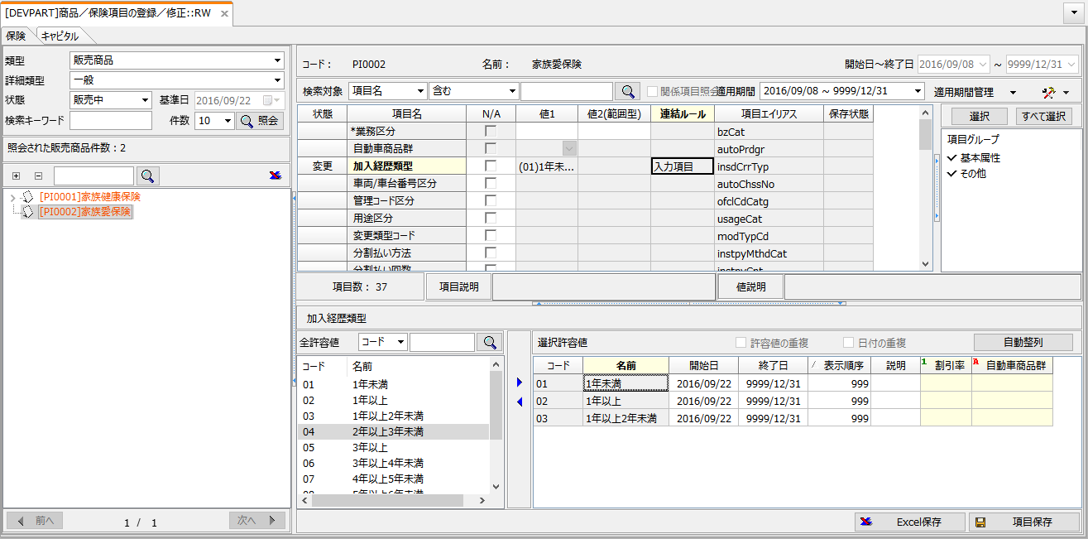

[Image 10 商品項目の登録／修正画面]

## OBJRELINC_PROP

When the RULE_KBN column value of the OBJ1200 table is 1 (input item), this table stores real values of the input item.

[Table 17 Main Column]

|  |  |  |
| --- | --- | --- |
| Column Name | Description | Remarks |
| **MULTIID** | ID for storing multiple item values |  |
| **SEQ** | Sequence |  |
| **CHAR01~50** | Column that stores character type values |  |
| **NUM10~20** | Column that stores numeric values |  |

[Table 18 Sample Data]

|  |  |  |  |
| --- | --- | --- | --- |
| MULTIID | SEQ | CHAR01 | NUM01 |
| 1 | 7 | 01 | 1.2 |
| 1 | 8 | 02 | 2.6 |
| 1 | 9 | 03 | 3.74 |

Table Description

Input items are used when adding information to an Attribute whose data type value is a multi-value.

Define input items whose data types are character and numeric values in the OBJ1400 table, and store the values of the input items in the OBJRELINC_PROP table.

* Related Screen



[Image 11 商品項目の登録／修正 – マルチ項目値の追加入力部分]

# Relation and Relation Rule Area

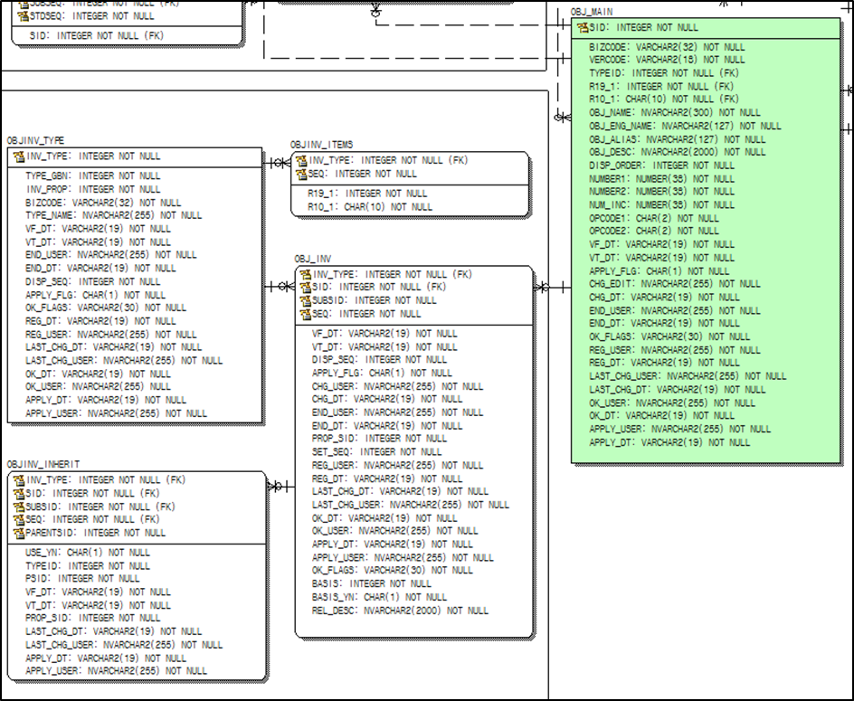

**OBJINV_TYPE**

**OBJ_INV**

**OBJ_MAIN**

[Image 12 Relation and Relation Rule Area Table]

## OBJINV_TYPE

It is a table for storing relation type information that can be used when generating a relation between objects.

[Table 19 Main Column]

|  |  |  |
| --- | --- | --- |
| Column Name | Description | Remarks |
| **INV_TYPE** | Relation Type ID |  |
| **TYPE_GBN** | Code Values that distinguish Relation Type | 1：Basic(Object) 4：Relation Rule 6：Service View |

[Table 20 Sample Data]

|  |  |  |
| --- | --- | --- |
| INV_TYPE | TYPE_GBN | TYPE_NAME |
| 1 | 1 | Basic |
| 2 | 6 | Service View |
| 3 | 4 | Required |
| 4 | 4 | Option |
| 5 | 4 | Must Together |
| 6 | 4 | Exclusive |

* Related Screen

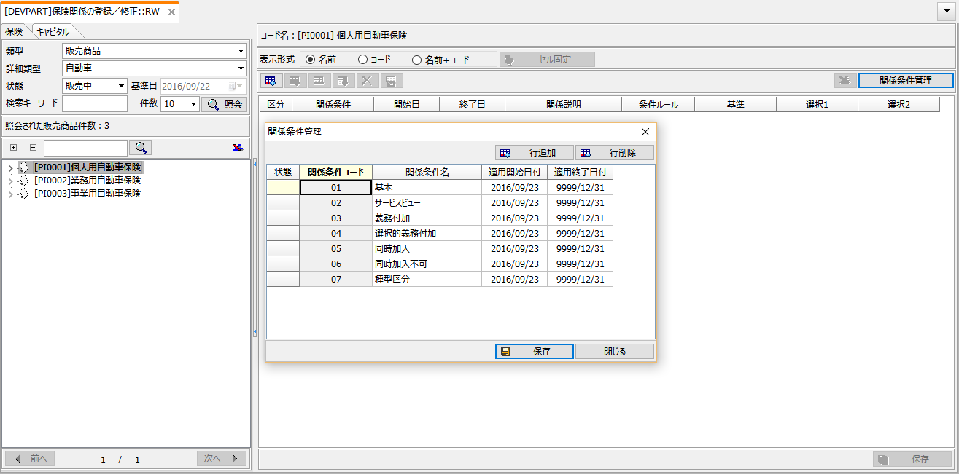

[Image 13 関係ルールの登録／修正 - 関係類型管理ポップアップ画面]

## OBJ_INV

It is a table for storing the relation between the upper and lower objects generated from the Relation Type and the Relation Rule.

[Table 21 Main Column]

|  |  |  |
| --- | --- | --- |
| Column Name | Description | Remarks |
| **INV_TYPE** | Relation Type ID | ID stored in OBJINV_TYPE |
| **SID** | ID of the upper level object | SID stored in OBJ_MAIN |
| **SUBSID** | ID of the lower level object | SID stored in OBJ_MAIN |
| **PROP_SID** | ID of Relation Object that is created when generating relation | SID stored in OBJ_MAIN |
| **SET_SEQ** | Order for distinguishing the same information when generating relational rules |  |
| **BASIS** | Code Values for distinguishing whether or not it is an object that works as the criteria when generating a relational rule | 0: not criteria  1: criteria |
| **BASIS_YN** | Code Values for distinguishing whether or not there is criteria when generating relation rules | Y: has criteria  N: has not criteria |
| **RULEID** | Rule ID of condition rule when relation rule defined condition rule |  |

[Table 22 Sample Data]

|  |  |  |  |  |  |
| --- | --- | --- | --- | --- | --- |
| INV_TYPE | SID | SUBSID | VF_DT | VT_DT | PROP_SID |
| 1 | 261 | 281 | 20150214 | 99991231 | 371 |
| 1 | 261 | 282 | 20150214 | 99991231 | 372 |
| 1 | 261 | 283 | 20150214 | 99991231 | 373 |
| 1 | 261 | 284 | 20150214 | 99991231 | 374 |
| 1 | 261 | 285 | 20150214 | 99991231 | 375 |
| 1 | 261 | 286 | 20150214 | 99991231 | 376 |
| 1 | 261 | 287 | 20150214 | 99991231 | 377 |

Table Description

When the INV_TYPE column is 1, the SID, SUBSID, and PROP_SID column values are the SID column values in the OBJ_MAIN table.

The ID of the upper object is stored in the SID of the OBJ_INV table. The ID of the lower object is stored in SUBSID, and the ID of the related object is stored in PROP_SID if there is a related object between the upper and lower objects.

In the sample data, there are subordinate objects 281, 282, and 283 (I2001, I2002, I2003... Coverage) below the object whose SID is 261 (P2001 product), and there are related objects between the upper and lower objects.

* Related Screen



[Image 14 商品構造の登録／修正画面]

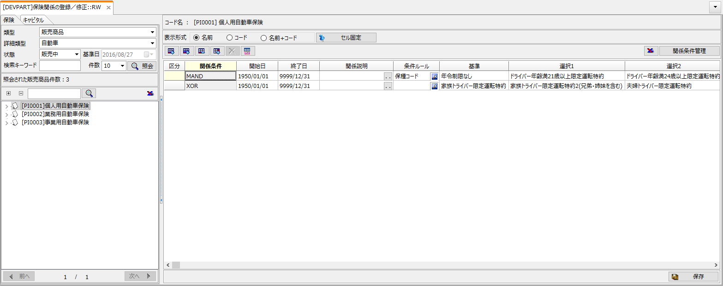

[Image 15 関係ルールの登録／修正画面]

1. Common information inquiry

# VF_DT、VT_DT

InnoProduct can manage the version of relation objects, relation rules, standard item values of objects, etc. according to the effective date.

* ‘20150225’ BETWEEN VF_DT AND VT_DT

When creating SQL, it is necessary to add VF_DT and VT_DT to the WHERE clause as shown above for the table with the effective date column

# END_DT

END_DT is a column representing the deletion date of the corresponding record stored with a default value of '99991231' (not deleted).

* END_DT = ‘99991231’

When InnoProduct deletes a record, it deletes the record logically by entering the deletion date in END_DT without physically deleting the record. Therefore, it is necessary to specify END_DT = ‘99991231’ in the WHERE clause when querying the value.

1. Querying structural information

# Object

Query Product list.

## Query General Product list

* This is a SQL to query a list of products whose semi-Type is “General”.

|  |
| --- |
| SELECT SID, BIZCODE, OBJ_NAME  FROM OBJ_MAIN  WHERE TYPEID = 901  AND END_DT = '99991231'  ORDER BY BIZCODE |

* Result

|  |  |  |  |  |
| --- | --- | --- | --- | --- |
| SID | BIZCODE | OBJ_NAME | VF_DT | VT_DT |
| 489 | P1001 | Family health insurance | 20150214 | 99991231 |

* WHERE CLAUSE
* WHERE TYPEID = 901

Semi-Type TYPEID is General.

## Query Car Product list

* This is a SQL to query a list of products whose semi-Type is “Car”.

|  |
| --- |
| SELECT SID, BIZCODE, OBJ_NAME  FROM OBJ_MAIN  WHERE TYPEID = 902  AND END_DT = '99991231'  ORDER BY BIZCODE |

* Result

|  |  |  |  |  |
| --- | --- | --- | --- | --- |
| SID | BIZCODE | OBJ_NAME | VF_DT | VT_DT |
| 261 | P2001 | Personal Car Insurance | 20150214 | 99991231 |
| 509 | P2002 | Commercial car insurance | 20150214 | 99991231 |

* WHERE CLAUSE
* WHERE TYPEID = 902

Semi-Type TYPEID is Car.

## Query products with a specific code

* SQL that queries products with a specific code among products whose semi-Type type is “Car”.

|  |
| --- |
| SELECT SID, BIZCODE, OBJ_NAME, VF_DT, VT_DT  FROM OBJ_MAIN  WHERE TYPEID = 902  AND BIZCODE = 'P2001'  AND END_DT = '99991231'  ORDER BY BIZCODE |

* Result

|  |  |  |  |  |
| --- | --- | --- | --- | --- |
| SID | BIZCODE | OBJ_NAME | VF_DT | VT_DT |
| 261 | P2001 | Personal Car Insurance | 20150214 | 99991231 |

* WHERE CLAUSE
* BIZCODE = ‘P2001’

Specify the product code in BIZCODE of the OBJ_MAIN table

## Query products with a specific name

* SQL to query products whose name starts with 'Personal' among products whose semi-Type type is “Car”.

|  |
| --- |
| SELECT SID, BIZCODE, OBJ_NAME, VF_DT, VT_DT  FROM OBJ_MAIN  WHERE TYPEID = 902  AND OBJ_NAME LIKE 'Personal%'  AND END_DT = '99991231'  ORDER BY BIZCODE |

* Result

|  |  |  |  |  |
| --- | --- | --- | --- | --- |
| SID | BIZCODE | OBJ_NAME | VF_DT | VT_DT |
| 261 | P2001 | Personal Car Insurance | 20150214 | 99991231 |

* WHERE CLAUSE
* OBJ_NAME LIKE ‘Personal%’

Specify a search keyword so that the value of OBJ_NAME in the OBJ_NAME table can be searched with the LIKE condition.

## Query entire product list

* SQL to query all objects whose Type is “Product”.

|  |
| --- |
| SELECT OM.SID, OM.TYPEID, OM.BIZCODE, OM.VF_DT, OM.VT_DT, OM.OBJ_NAME  FROM OBJ_MAIN OM, OBJ1000 O10  WHERE OM.TYPEID = O10.TYPEID  AND O10.PTYPEID = 10  AND OM.END_DT = '99991231'  AND '20150225' BETWEEN OM.VF_DT AND OM.VT_DT  ORDER BY BIZCODE |

* Result

|  |  |  |  |  |  |
| --- | --- | --- | --- | --- | --- |
| SID | TYPEID | BIZCODE | VF_DT | VT_DT | OBJ_NAME |
| 489 | 901 | P1001 | 20150214 | 99991231 | Family Health Insurance |
| 261 | 902 | P2001 | 20150214 | 99991231 | Personal Car Insurance |
| 509 | 902 | P2002 | 20150214 | 99991231 | Commercial Car Insurance |

* WHERE CLAUSE
* WHERE OM.TYPEID = O12.TYPEID

AND O12.PTYPEID = 10

In order to query the entire product, query the object whose PTYPEID in the OBJ1000 table is 10 (“Product” Type ID).

# Relation

Query a list of coverage below a specific product.

* SQL to query the coverage below the P2001 product.

|  |
| --- |
| SELECT OM1.BIZCODE AS PBIZCODE, OM1.OBJ_NAME AS PNAME,  OM2.BIZCODE AS IBIZCODE, OM2.OBJ_NAME AS INAME  FROM OBJ_MAIN OM1, OBJ_INV OI, OBJ_MAIN OM2  WHERE OM1.SID = OI.SID  AND OI.SUBSID = OM2.SID  AND OI.INV_TYPE = 1  AND OM1.END_DT = '99991231'  AND OI.END_DT = '99991231'  AND OM2.END_DT = '99991231'  AND OM1.SID = 261  AND '20150225' BETWEEN OM2.VF_DT AND OM2.VT_DT  ORDER BY OM2.BIZCODE |

* Result (Partially omitted)

|  |  |  |  |  |
| --- | --- | --- | --- | --- |
| PBIZCODE | PNAME | IBIZCODE | INAME | … |
| P2001 | Personal Car Insurance | I2001 | Criminal agreement support costs guarantee | … |
| P2001 | Personal Car Insurance | I2002 | Lawyer appointment costs guarantee | … |
| P2001 | Personal Car Insurance | I2003 | Fine fee guarantee | … |
| … | … | … | … | … |

* WHERE CLAUSE
* WHERE OM1.SID = OI.SID

AND OI.SUBSID = OM2.SID

The SID of the product object is matched with the SID of the OBJ_INV table, and the coverage object ID, which is the subordinate of the product, is matched with the SUBSID. This is a query that inquires about products and coverages together.

* OI.INV_TYPE = 1

INV_TYPE in the OBJIJV_TYPE table is “Basic”.

* OM1.SID = 261

This is the ID of the product object to be queried.

# Relation Rule

Query relation rule information specified between subordinate objects

* SQL to query the relation rule below the P2001 product.

|  |
| --- |
| SELECT OIT.TYPE_NAME, OI.INV_TYPE, OM1.BIZCODE AS PBIZCODE, OM1.OBJ_NAME AS PNAME,  OI.SET_SEQ, OI.BASIS, OI.BASIS_YN, OM2.BIZCODE AS IBIZCODE,  OM2.OBJ_NAME AS INAME  FROM OBJ_MAIN OM1, OBJ_INV OI, OBJ_MAIN OM2, OBJINV_TYPE OIT  WHERE OM1.SID = OI.SID  AND OI.SUBSID = OM2.SID  AND OM1.SID = 261  AND OI.INV_TYPE = OIT.INV_TYPE  AND OIT.TYPE_GBN = 4 |

* Result (Partially omitted)

| TYPE_NAME | INV_ TYPE | PBIZCODE | PNAME | SET _SEQ | BASIS | BASIS_YN | IBIZ CODE | INAME |
| --- | --- | --- | --- | --- | --- | --- | --- | --- |
| Exclusive | 6 | P2001 | Personal Car Insurance | 1 | 1 | Y | I2040 | No age limit |
| Exclusive | 6 | P2001 | Personal Car Insurance | 1 | 0 | N | I2041 | From 21-years -old Limited driver |
| Exclusive | 6 | P2001 | Personal Car Insurance | 1 | 0 | N | I2042 | From 30-years -old Limited driver |
| Exclusive | 6 | P2001 | Personal Car Insurance | 2 | 1 | Y | I2034 | Only one registered insured person |
| Exclusive | 6 | P2001 | Personal Car Insurance | 2 | 0 | N | I2036 | Couple driver only |

|  |  |  |  |  |  |  |  |  |
| --- | --- | --- | --- | --- | --- | --- | --- | --- |
| … | … | … | … | … | … | … | … | … |

* WHERE CLAUSE
* OI.INV_TYPE = OIT.INV_TYPE

Join the OBJ_INV and OBJINV_TYPE tables to query all relation types.

* OIT.TYPE_GBN = 4

Query the relation type information of the relation rule in the OBJINV_TYPE table.

* Result Column

Query necessary relation rule information through table Join.　 The following is the definition on the InnoProduct screen.

|  |  |  |  |  |  |  |  |
| --- | --- | --- | --- | --- | --- | --- | --- |
| Relation Condition | criteria | Selection1 | | | Selection2 | | Selection… |
| Exclusive | No age limit | From 21-years -old Limited driver | | | From 30-years -old Limited driver | | … |
| Exclusive | Only one registered insured person | Couple driver only | | |  | |  |

* SET_SEQ

Two relation rules are saved in the above InnoProduct screen. Two ROWs are distinguished by SET_SEQ value in OBJ_INV table.

* BASIS、BASIS_YN

In the same SET_SEQ, the criteria object has a BASIS column value of 1, and the BASIS_YN column value is Y.

# Service View

## Service View list

Query service view list.

* SQL to query the service view list below the P2001 product.

|  |
| --- |
| SELECT OM1.BIZCODE AS PBIZCODE, OM1.OBJ_NAME AS PNAME, OM2.BIZCODE AS IBIZCODE, OM2.OBJ_NAME AS INAME, OM2.SID AS ISID  FROM OBJ_MAIN OM1, OBJ_INV OI, OBJ_MAIN OM2  WHERE OM1.SID = OI.SID  AND OI.SUBSID = OM2.SID  AND OI.INV_TYPE = 2  AND OM1.SID = 261  AND OM1.END_DT = '99991231'  AND OI.END_DT = '99991231'  AND OM2.END_DT = '99991231' |

* Result

|  |  |  |  |  |
| --- | --- | --- | --- | --- |
| PBIZCODE | PNAME | IBIZCODE | INAME | ISID |
| P2001 | Personal Car Insurance | S2001 | Sale Plan A | 447 |
| P2001 | Personal Car Insurance | S2002 | Sale Plan B | 448 |

* WHERE CLAUSE
* OI.INV_TYPE = 2

Query only those whose relation type is service view.

* OM1.SID = 261

ID of P2001 product

## Service View Structure

Query the structure of Service View.

* SQL to query the structure of the S2001 service view.

|  |
| --- |
| SELECT OM1.BIZCODE AS PBIZCODE, OM1.OBJ_NAME AS PNAME, OM2.BIZCODE AS IBIZCODE, OM2.OBJ_NAME AS INAME  FROM OBJ_MAIN OM1, OBJ_INV OI, OBJ_MAIN OM2  WHERE OM1.SID = OI.SID  AND OI.SUBSID = OM2.SID  AND OI.INV_TYPE = 2  AND OM1.SID = 447  AND OM1.END_DT = '99991231'  AND OI.END_DT = '99991231'  AND OM2.END_DT = '99991231' |

* Result(Partially omitted)

|  |  |  |  |
| --- | --- | --- | --- |
| PBIZCODE | PNAME | IBIZCODE | INAME |
| S2001 | Sale Plan A | I2005 | Injury article support |
| S2001 | Sale Plan A | I2006 | Injury nursing fee support |
| S2001 | Sale Plan A | I2007 | Other vehicle damage |
| … | … | … | … |

* WHERE CLAUSE
* OI.INV_TYPE = 2

Query only those whose relation type is service view.

* OM1.SID = 447

Service view object ID.

1. Attribute Info

# Attribue

Query informations of attributes of a specific semi-Type.

* SQL to query attribute information whose semi-Type is “Car” (902).

|  |
| --- |
| SELECT O11.GROUPNAME, O12.PROP_TYPE, O12.DISP_NAME, O12.DISP_TYPE, O12.PHY_COLUMN1, O12.PHY_COLUMN2, O12.ITEM_ID, O12.DATA_TYPE, O12.ALIAS, O12.DISP_ORDER  FROM OBJ1100 O11, OBJ1110 O11_1, OBJ1200 O12  WHERE O11_1.TYPEID = 902  AND O11.TYPEID = O11_1.TYPEID  AND O11.GROUPSEQ = O11_1.GROUPSEQ  AND O11_1.ITEMID = O12.ITEMID |

* Result(Partially omitted)

|  |  |  |  |  |
| --- | --- | --- | --- | --- |
| GROUPNAME | PROP_TYPE | DISP_NAME | PHY_COLUMN1 | … |
| Basic | 1 | Product Name | CHAR09 | … |
| Basic | 1 | Business Category | CHAR10 | … |
| Basic | 1 | Car Insurance Group | CHAR14 | … |
| Other | 1 | Existence of traffic law violation types | CHAR01 | … |
| Other | 1 | Named insured driving | CHAR02 | … |
| … | … | … | … | … |

* WHERE CLAUSE
* O11.TYPEID = O11_1.TYPEID  
  O11.GROUPSEQ = O11_1.GRPOUPSEQ  
  O11_1.ITEM_ID = O12.ITEM_ID

Join OBJ1100 table and OBJ1110 table to query group information of attributes.

* O11.TYPEID = 902

TYPEID whose semi-Type is “Car”.

# Single Value of Attribute

Query the value of attribute that has a single value for a specific object

* SQL to query the value of attribute that has a single value for a specific object

|  |
| --- |
| SELECT OM.BIZCODE, OM.OBJ_NAME, OD.SID, OD.KIND, OD.VF_DT, OD.VT_DT, OD.CHAR09  FROM OBJ_MAIN OM, OBJ_DETAIL OD  WHERE OM.SID = OD.SID  AND OM.SID = 261  AND OM.END_DT = '99991231'  AND OD.END_DT = '99991231'  AND OD.KIND = 1  AND ‘20150225’ BETWEEN OD.VF_DT AND OD.VT_DT |

* Result

|  |  |  |  |  |  |  |
| --- | --- | --- | --- | --- | --- | --- |
| BIZCODE | OBJ_NAME | SID | KIND | VF_DT | VT_DT | CHAR09 |
| P2001 | Personal Car Insurance | 261 | 1 | 20150214 | 99991231 | Innocar Personal Car Insurance |

* WHERE CLAUSE
* OM.SID = OD.SID

Join the OBJ_MAIN table to query the product object information.

* OD.KIND = 1

Query only attributes.

# Multiple Value of Attribute

Query the value of attribute that has a multiple value for a specific object.

Multiple Value Attributes store the value of MULTIID in the OBJ_DETAIL table.

The SQL below is created after confirming the attribute value “Payment Method” from the OBJ_DETAIL table.

* SQL to query the value of the "Payment Method" attribute for P2001 products

|  |
| --- |
| SELECT REL.MULTIID, REL.RULE_ID, INC.VF_DT, INC.VT_DT, INC.SID, OM.BIZCODE, OM.OBJ_NAME  FROM OBJ_REL REL, OBJREL_INC INC, OBJ_MAIN OM  WHERE REL.MULTIID = INC.MULTIID  AND REL.MULTIID = 1  AND INC.SID = OM.SID  AND REL.END_DT = '99991231'  AND INC.END_DT = '99991231' |

* Result

|  |  |  |  |  |  |  |
| --- | --- | --- | --- | --- | --- | --- |
| MULTIID | RULE_ID | VF_DT | VT_DT | SID | BIZCODE | OBJ_NAME |
| 1 |  | 20150227 | 99991231 | 56 | 01 | Lump sum payment |
| 1 |  | 20150227 | 99991231 | 57 | 02 | General installments |
| 1 |  | 20150227 | 99991231 | 58 | 03 | Annual payment |

* WHERE CLAUSE
* REL.MULTIID = INC.MULTIID

The OBJ_REL table stores MULTIID, which is the ID of the value of multiple value attribute. When the value of multiple value attribute is a rule, the rule ID is stored in the RULE_ID column of the OBJ_REL table.

* REL.MULTIID = 1

MULTIID of the "Payment Method" attribute for P2001 products

* INC.SID = OM.SID

In the OBJREL_INC table, the SID of the allowed value of the attribute is stored. To query the code and name, JOIN with the OBJ_MAIN table.

1. Table Property

Query the value of a table property for a specific object

* SQL to query the value of the “Product Name” item in the Table Property information of P2001 product.

|  |
| --- |
| SELECT OM.BIZCODE, OM.OBJ_NAME, OD.SID, OD.KIND,  OD.CHAR03 AS “Danger Class Code”, OD.CHAR02 AS “Minimum Age”,  OD.CHAR04 AS “Maximum Age”, OD.CHAR05 AS “End Date”,  OD.CHAR07 AS “Start Date”  FROM OBJ_MAIN OM, OBJ_DETAIL OD  WHERE OM.SID = OD.SID  AND OM.SID = 261  AND OM.END_DT = '99991231'  AND OD.KIND = 1001 |

* Result (Partially omitted)

|  |  |  |  |  |  |  |  |  |
| --- | --- | --- | --- | --- | --- | --- | --- | --- |
| BIZCODE | OBJ_NAME | SID | KIND | Danger Class Code | Minimum Age | Maximum Age | End Date | Start Date |
| P2001 | Personal Car Insurance | 261 | 1,001 | 2 | 10 | 60 | 20150214 | 99991231 |
| P2001 | Personal Car Insurance | 261 | 1,001 | 2 | 20 | 59 | 20150214 | 99991231 |
| P2001 | Personal Car Insurance | 261 | 1,001 | 3 | 30 | 61 | 20150214 | 99991231 |
| … | … | … | … | … | … | … | … | … |

* WHERE CLAUSE
* OD.KIND = 1001

This is the TYPEID of the table property.

1. Other

# Query product list with specific attribute values

* SQL to query car insurance products whose attribute value is "MT"

|  |
| --- |
| SELECT OM.VF_DT, OM.VT_DT, OM.BIZCODE, OM.OBJ_NAME, OD.CHAR10  FROM OBJ_MAIN OM, OBJ_DETAIL OD  WHERE OM.SID = OD.SID  AND OD.CHAR10 = 'MT'  AND OD.KIND = 1  AND OM.END_DT = '99991231'  AND OD.END_DT = '99991231' |

* Result

|  |  |  |  |  |
| --- | --- | --- | --- | --- |
| VF_DT | VT_DT | BIZCODE | OBJ_NAME | CHAR10 |
| 20150214 | 99991231 | P2001 | Personal Car Insurance | MT |
| 20150214 | 99991231 | P2002 | Commercal Car Insurance | MT |

* WHERE CLAUSE
* OM.SID = OD.SID

Join the OBJ_MAIN table and OBJ_DETAIL table in order to inquire information about products and attributes at the same time.

* OD.CHAR10 = 'MT'

Add CHAR10 column, which is the attribute for search, to WHERE CLAUSE.

# Query product list with specific coverage in the lower level

* SQL to query the list of products that have coverage "I2001" in the lower level.

|  |
| --- |
| SELECT OM.BIZCODE, OM.OBJ_NAME, OM2.BIZCODE, OM2.OBJ_NAME  FROM OBJ_MAIN OM, OBJ_INV OI, OBJ_MAIN OM2  WHERE OM.SID = OI.SID  AND OI.SUBSID = OM2.SID  AND OM2.BIZCODE = 'I2001'  AND OM.END_DT = '99991231'  AND OI.END_DT = '99991231' |

* Result

|  |  |  |  |
| --- | --- | --- | --- |
| BIZCODE | OBJ_NAME | BIZCODE_1 | OBJ_NAME_1 |
| P2001 | Personal Car Insurance | I2001 | Criminal agreement support money |
| P2002 | Commercal Car Insurance | I2001 | Criminal agreement support money |

* WHERE CLAUSE
* OM2.BIZCODE = ‘I2001’

Query products whose code value (BIZCODE) is “I2001” that matches SUBSID (subordinate object) in OBJ_INV table

# Query a list of products that have coverage with a specific attribute value in the lower level

* SQL to query a list of products that have coverage with the attribute ("abbreviation") value as "CAR_INS"

|  |
| --- |
| SELECT OM.BIZCODE, OM.OBJ_NAME, OM2.BIZCODE, OM2.OBJ_NAME, OD.CHAR07  FROM OBJ_MAIN OM, OBJ_INV OI, OBJ_MAIN OM2, OBJ_DETAIL OD  WHERE OM.SID = OI.SID  AND OI.SUBSID = OM2.SID  AND OI.SUBSID = OD.SID  AND OM.END_DT = '99991231'  AND OI.END_DT = '99991231'  AND OM2.END_DT = '99991231'  AND OD.CHAR07 = 'CAR_INS' |

* Result

|  |  |  |  |  |
| --- | --- | --- | --- | --- |
| BIZCODE | OBJ_NAME | BIZCODE_1 | OBJ_NAME_1 | CHAR07 |
| P2001 | Personal Car Insurance | I2002 | Lawyer appointment costs | CAR_INS |
| P2002 | Commercal Car Insurance | I2002 | Lawyer appointment costs | CAR_INS |

* WHERE CLAUSE
* OI.SUBSID = OD.SID

To search for coverage attribute values, join the SUBSID column of the OBJ_INV table and the SID of the OBJ_DETAIL table

* OD.CHAR07 = ‘CAR_INS’

Add CHAR07 to WHERE CLAUSE to search for the value of "abbreviation" (CHAR07).

# When the attribute value is a rule

Rules can be saved as single-value item, table property data, multiple-value item, relation rule values

* single-value item/ table property data : Save the rule ID as ‘# S00000050’ in the CHARXX column of OBJ_DETAIL
* multi-value item : MULTIID is stored in CHARXX column of OBJ_DETAIL, and rule ID is stored in RULE_ID column of OBJ_REL table as ‘# S00000050’.
* relation rule : Save the rule ID in the RULEID column of OBJ_INV. Save the same rule ID in the SET_SEQ column.

Execute the queried rule using the EXECRULE function and return the result

|  |  |
| --- | --- |
| Result | Condition |
| EXECRULE([Attribute Value]) | LEFT([Attribute Value],2)="#S" |



1. Creating SQL with Rule Builder

In Rule Builder, input items can be used for SQL WHERE CLAUSE when creating DB rules

* SQL to query objects of semi-Type "General" (901)

|  |
| --- |
| SELECT SID, BIZCODE, OBJ_NAME  FROM OBJ_MAIN  WHERE TYPEID = 901  AND END_DT = '99991231'  ORDER BY BIZCODE |

In DB rules, TYPEID 901 can be substituted for input items as shown below.

|  |
| --- |
| SELECT SID, BIZCODE, OBJ_NAME  FROM OBJ_MAIN  WHERE TYPEID = '<$$[semi-Type ID]$$>'  AND END_DT = '99991231'  ORDER BY BIZCODE |